GCSE Foundation Level Data 1 & 2 Supplementary information

Data set 1

Mehreen did a survey about the pets that her friends own. She put the results is a 2 way table.

|  |  |  |  |
| --- | --- | --- | --- |
|  | Pet | No pet | Total |
| Boy | 7 | 10 |  |
| Girl | 15 | 18 |  |
|  |  |  |  |

Data set 2

The table shows the type of studies of a group of students.

|  |  |  |  |  |
| --- | --- | --- | --- | --- |
|  | Science | Humanities | Arts | Total |
| Female | 22 |  | 23 | 74 |
| Male |  |  |  |  |
| Total | 45 | 57 |  | 165 |

Data set 3

This survey shows how many times a group of people visited Asdi supermarket in September:

|  |  |  |  |  |  |  |  |  |
| --- | --- | --- | --- | --- | --- | --- | --- | --- |
|  |  |  |  |  |  |  | Score | frequency |
| 24 | 11 | 20 | 1 | 19 | 19 |  | 1 - 5 |  |
| 23 | 25 | 12 | 9 | 18 | 14 |  | 6 – 10 |  |
| 25 | 6 | 15 | 12 | 7 | 11 |  | 11 – 15 |  |
| 5 | 2 | 15 | 9 | 16 | 15 |  | 16 – 20 |  |
|  |  |  |  |  |  |  | 21 - 25 |  |
|  |  |  |  |  |  |  |  |  |

Data set 4

Envelopes arriving one day at Hoseph Jamberlain College were measured. The widths, in cm, were as follows:

|  |  |  |  |  |  |  |  |  |
| --- | --- | --- | --- | --- | --- | --- | --- | --- |
|  |  |  |  |  |  |  | Score | frequency |
| 11.8 | 10.3 | 20.5 | 15.4 | 19.2 |  |  | 5 ≤ w < 10 |  |
| 17.0 | 22.7 | 12.8 | 9.7 | 18.9 |  |  | 10 ≤ w < 15 |  |
| 20.4 | 8.1 | 15.9 | 12.2 | 20.6 |  |  | 15 ≤ w < 20 |  |
| 6.9 | 10.0 | 11.3 | 10.0 | 16.1 |  |  | 20 ≤ w < 25 |  |
|  |  |  |  |  |  |  |  |  |

Data set 5

The pupils in a class at a secondary school were asked what their favourite sport was. A pictogram was shown of the results.

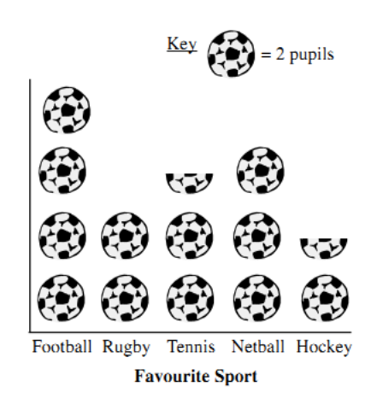

Data set 6

The graph shows the temperature over one day in June.

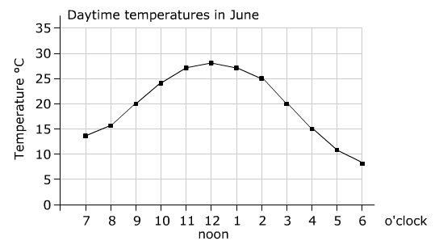

Data set 7

A group of 180 people were asked which was their favourite Simpsons family character. A pie chart was drawn of the results.

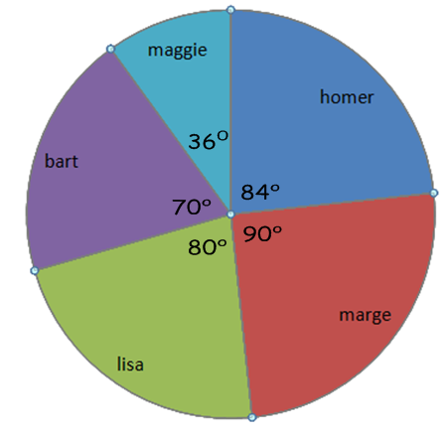

Data set 8

The histogram shows the lengths of alligators found in a river in Australia.  
There are 50 alligators between 120 cm and 140 cm in length.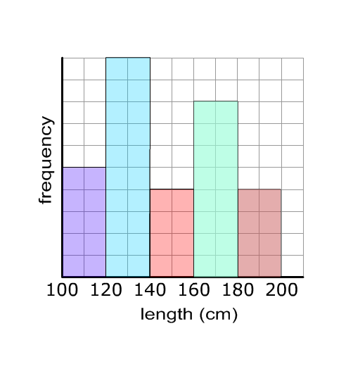

Data set 9

The stem and leaf diagram shows the ages of people at a party.

|  |  |  |  |  |  |  |  |  |  |  |  |  |
| --- | --- | --- | --- | --- | --- | --- | --- | --- | --- | --- | --- | --- |
| 1 | 3 | 4 | 8 | 8 | 9 |  |  |  |  |  |  |  |
| 2 | 0 | 1 | 2 | 2 | 4 | 6 | 6 | 6 | 8 |  |  |  |
| 3 | 1 | 1 | 2 | 2 |  |  |  |  |  |  |  |  |
| 4 | 2 | 3 | 6 |  |  |  |  |  |  |  |  |  |
| 5 | 1 | 8 | 9 |  |  |  |  |  |  |  |  |  |
| 6 | 5 | 9 |  |  |  |  |  |  |  |  |  |  |
| 7 | 6 |  |  |  |  |  |  |  |  |  |  |  |

|  |  |  |  |  |
| --- | --- | --- | --- | --- |
| Key: | 1 | 3 | = 13 years |  |

Data set 10

The stem and leaf diagram shows the weights of two groups of male 20 year olds, from towns A and B.

|  |  |  |  |  |  |  |  |  |  |  |  |  |  |  |  |  |  |  |  |  |  |
| --- | --- | --- | --- | --- | --- | --- | --- | --- | --- | --- | --- | --- | --- | --- | --- | --- | --- | --- | --- | --- | --- |
|  |  |  |  |  |  | 5 | 1 | 0 | 0 | 6 | 2 | 2 | 3 | 4 |  |  |  |  |  |  |  |
|  |  |  |  |  |  |  | 6 | 4 | 2 | 7 | 1 | 7 | 8 | 9 |  |  |  |  |  |  |  |
| Town A |  |  |  |  | 7 | 7 | 6 | 5 | 1 | 8 | 0 | 4 | 4 | 4 | 6 |  |  |  |  |  | Town B |
|  |  |  |  |  | 9 | 8 | 7 | 4 | 0 | 9 | 0 | 2 | 3 | 5 | 5 | 9 |  |  |  |  |  |
|  |  |  |  | 6 | 4 | 2 | 2 | 2 | 1 | 10 | 2 | 3 | 3 | 4 | 6 | 6 | 7 | 9 |  |  |  |

|  |  |  |  |
| --- | --- | --- | --- |
| Key: | 7 | 5 | = 75 kg |

Data set 11

A group of people were asked the question: “How many times did you shop at the supermarket last week?” Their responses are summarised in the table:

|  |  |
| --- | --- |
| Number  of visits | frequency |
| 0 | 3 |
| 1 | 4 |
| 2 | 5 |
| 3 | 6 |
| 4 | 2 |
| 5 | 3 |

Data set 12

The time it took to complete a frame of snooker at a tournament was recorded as follows:

|  |  |
| --- | --- |
| Time taken  (minutes) | frequency |
| 0 < t ≤ 10 | 10 |
| 10 < t ≤ 20 | 18 |
| 20 < t ≤ 30 | 17 |
| 30 < t ≤ 60 | 14 |